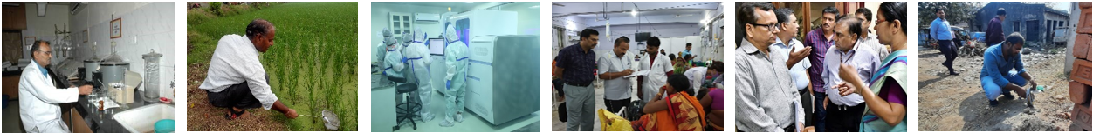
ISSN 2583-0163

Director’s Desk
Thematic Area: Biosafety and Biosecurity
Lead Story………………..………………………………….….1
- Establishment of High Containment laboratories for Handling in High Threat Pathogens
Surveillance Focus ………………………….…….....................5
- Surveillance and Response to Anthrax outbreak: Laboratory support
Outbreak Section…...............................................…………......6
- Outbreak of Avian Influenza in Odisha, August 2024
- Field Epidemiological Investigation of AES/Chandipura Virus Cases and Deaths: Deployment of Central Team to Support Gujarat's State Epidemic Cell
- Outbreak Investigation of Acute Diarrhoeal Disease in Uprari Village, Almora, July 2025
NCDC News………..............................................................…..12
- EIS Officers train in R Programming for Enhanced Epidemiological Analysis
NCDC Branches….....…...........................................................14
- National Centre for Disease Control, Varanasi Branch statement of work done from Jul 2024 to Sep 2024 (3rd quarter)
Global Disease Alert ……………….……………….…............15
NCDC Buzz.....………….....…………….….............................17
Lead Story: Establishment of High Containment laboratories for Handling in High Threat Pathogens
Contributed by: Ms Yosman¹, Ms Sharda Singh², Dr Monil Singhai³
Peer reviewed by: Dr Purva Pankaj Sakarte³, Dr Aarti Tewari³
¹Assistant Research Officer, NCDC; ²Research Assistant, NCDC; ³Joint Director, NCDC

Biosafety Levels (BSL) laboratories are standardized prototypes that define the containment practices, facility design, safety equipment, and operational protocols required to handle biological agents of varying pathogenicity and transmissibility. There are four levels of containment laboratories, designated as BSL-1 to BSL-4, each providing increasing levels of protection to personnel, the environment, and the community.
Containment forms the core of biosafety and refers to the methods used to manage infectious materials safely in the laboratory environment. It can be categorized into:
- Primary containment, which involves the protection of personnel and the immediate laboratory environment through the use of safety equipment such as biological safety cabinets,
Thematic Area: Biosafety and Biosecurity
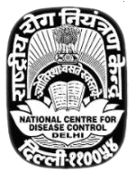 | Biosafety and biosecurity are complementary pillars that safeguard people, environments, and research integrity in medical science. Biosafety is preventing unintentional exposure to, or release of, infectious agents and biological hazards through risk assessment, containment, and safe laboratory practices. The Core elements include appropriate biosafety levels (BSL-1 to BSL-4), engineering controls (e.g., biosafety cabinets), personal protective equipment, standard operating procedures, and training. Biosecurity addresses the intentional misuse, theft, or diversion of biological materials, knowledge, and technologies.  For countries like India, with a high burden of communicable diseases and increasing research
in the field of biotechnology, strengthening biosafety and biosecurity is not just a technical requirement but a pressing public health need. In this context, public health institutions play a central role in research, regulation, outbreak preparedness, and capacity building. This issue of the newsletter emphases the topic “Biosafety and Biosecurity”.
The current newsletter includes an article in Handling High Threat Pathogen Laboratory; Establishment and Operation, this also includes an article on role of apex laboratory at NCDC during outbreak of human Anthrax cases in India. The current issues also include outbreak investigations conducted. The other sections of this report briefly summarise the various activities undertaken at NCDC and its branches during the third quarter of year 2025.
We hope that this newsletter provides you with valuable insights and updates. Inputs and ideas to improve it further are welcome.

Highlights in this issue
NCDC Newsletter
Volume 13, Issue 3 Jul’24 to Sep’24

Quarterly Newsletter from National Centre for Disease Control (NCDC)

personal protective equipment (PPE), and good microbiological practices.  - Secondary containment, which provides protection to the environment external to the laboratory through facility design features such as controlled access, specialized ventilation systems, air filtration, and waste decontamination. |  | Bio-risk assessment and mitigation are principles/ procedures required to select appropriate bio-safety level laboratories for each hazard group pathogen (Biohazard group 1-4) based on procedure planned and risk involved. The aim should be to select appropriate controls and BSL level laboratory to reduce risk score to as low as possible (1).

Biosafety Level | Type of Agents Handled | Containment Features | Examples
BSL-1 | Agents not known to consistently cause disease in healthy adult humans. | Standard microbiological practices, open bench work, hand washing sink, and basic PPE. | Bacillus subtilis, E. coli (non-pathogenic strains)
BSL-2 | Agents associated with human diseases that pose moderate hazards through percutaneous injury, ingestion, or mucous membrane exposure. | Access control, biological safety cabinets (Class II), autoclave for waste decontamination, and training in pathogen handling. | Culture of Salmonella spp., (diagnostic specimens only)
BSL-3 | Indigenous or exotic agents that may cause serious or potentially lethal disease through inhalation. | Controlled access, directional negative airflow, HEPA filtration of exhaust air, sealed laboratory structure, and specialized PPE. | Culture of Mycobacterium tuberculosis,
BSL-4 | Dangerous and exotic agents posing high risk of life-threatening disease, aerosol transmission, or for which no treatment or vaccine exists. | Full-body, air-supplied positive pressure suits, dedicated building with complete isolation, double HEPA-filtered exhaust, and chemical shower upon exit. | Culture of Ebola virus, Marburg virus

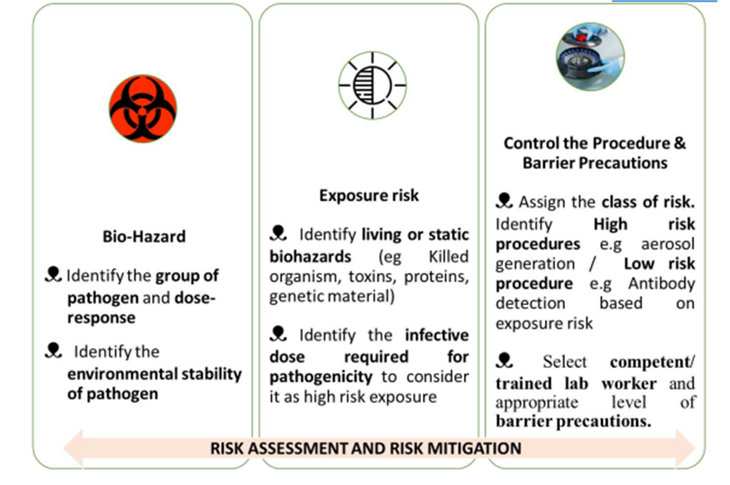

Stages in Establishment of High Containment Laboratories: There has been an increasing global emphasis on the establishment and containment of BSL-3 and BSL-4 laboratories following the COVID-19 pandemic. These high-containment facilities are now recognized as integral components of public health preparedness and response, particularly for managing outbreaks caused by high-threat pathogens. However, given the critical concerns related to biosafety, biosecurity, and dual-use research particularly in regions with weak bio-risk management oversight it is imperative that laboratories are established under strict compliance with national and international biosafety standards to ensure safe and secure operations only where requirement is essential.  Biological threats, whether naturally emerging, accidentally released, or deliberately introduced, have the potential to endanger lives and disrupt economies worldwide (2). Therefore, a clear understanding of fundamental biosafety and biosecurity principles is crucial for the establishment and operation of high-containment laboratories such as BSL-3 and BSL-4. However, lack of a comprehensive governance framework in most of the countries for high containment laboratories is the overarching, most salient and germane issue. In this context, India has recently launched the National One Health Mission, which |  | aims to establish a coordinated network of laboratories at central and field levels. The mission seeks to strengthen diagnostic capacity and foster collaboration among the human, animal, wildlife, and environmental sectors. By leveraging the complementary strengths of each domain, the mission aspires to develop an integrated, robust, and agile system for outbreak preparedness and response (3).  The requirements of environmental safety, occupational safety, biosecurity, and social safeguards to mitigate potential negative impacts and risks associated with the design, construction, and operation of high-containment laboratories must be integrated from the pre-planning stage itself (4). These aspects should be systematically evaluated and reassessed at every subsequent phase, in accordance with the prevailing national rules, regulations, and international best practices. The stages in establishment and operations of high containment laboratories and components requiring focus are detailed as follows:  Specialized High Containment laboratory variants: The establishment of high-containment laboratories must consider the nature of pathogens handled, type of experimental work, and potential agricultural or environmental impact. Many of the laboratory procedures for Dangerous pathogens which are commonly employed during initial processing or downstream manipulation of clinical specimens or

- Pre-planning (Regulatory assessments, Environmental impact assessments, Safety/Security assessment).
- Planning (Design)
- Construction (Civil work, Electricity, Plumbing, Safety equipment supply and installation)
- Commissioning (Testing and Calibration of Building Management System, Validation, Certifications).
- Operations (Demonstration, Training, SOPs, Workflows, Guidelines Maintenance).
- Accreditation (ISO/IEC 17025 - Testing and Calibration Laboratories, ISO 9001:2015 Quality Management Systems, ISO 14001:2015-Environmental Management System, ISO 45001:2018 Occupational Health and Safety, ISO/IEC 27001:2022 Information Security, Cyber Security and Privacy Protection, Information Security Management System etc.)
Stages in Establishment of BSL-3/4 laboratory

cultures have the potential to generate infectious droplets. Moreover, due to availability of Point of care test and molecular transport medium vials which can inactivate the sample and render it safe to handle in BSl-2 laboratories for downstream applications such as PCR the role of standard BSL-3 laboratories is limited.  However, Specialized BSL-3 laboratory variants such as ABSL-3, AgBSL-3 play a critical role in advancing zoonotic research, vaccine development, and bio-preparedness, while ensuring that all work is performed under strict |  | biosafety and biosecurity oversight. The brief description of standard and specialized BSL 3 laboratory variants is given in Table2 adopted from description by Heckert et al. (5)  Conclusion: As global health systems strengthen their preparedness for emerging and re-emerging infectious diseases, these high-containment facilities serve as vital assets for surveillance, diagnostics, and vaccine development. Thus, the establishment and operation of high containment laboratories demand meticulous attention to biosafety, biosecurity, and environmental safety.

BSL-3  (Biosafety level-3) | ABSL-3  (Animal Biosafety level-3) | BSL3-Ag  (Biosafety level -3 Agriculture Pathogens)
Laboratory facility and practices include  - Inward directional airflow, Separation from non-laboratory areas,  - Special laboratory protective clothing,  - Safety equipment (biosafety cabinet, centrifuge)  - Dynamic pass box for aseptic transfer of materials  - Decontamination of laboratory waste (air, liquid, solid by High Efficiency Particulate Air filter, Biological Laboratory Effluent Decontamination Systems, Effluent treatment plants and Double door autoclaves | BSL3 level plus experimental work with some highly infectious agriculture agents in small animals can be done and requires  - Placing animals in isolation containers with HEPA filtration of supply and exhaust air,  - Sewage decontamination,  - Personnel exit showers,  - Facility integrity testing (pressure decay test). | This facility is used when large animals such as cows, pigs, bison and deer, are infected with high consequence agricultural pathogens and cannot be placed inside any other animal isolation device.  - Facility barriers, usually considered secondary barriers, now act as primary barriers.
E.g Culture of Mycobacterium tuberculosis, SARS-CoV-2 | E.g Collection oropharyngeal and cloacal swabs, tracheal swabs, and fecal samples from Birds suspected of High Pathogenic avian influenza infection | E.g Autopsy (Necropsy) of Cattle Suspected for Anthrax, Necropsy on a Plague-suspected animal
Table 2: Brief description of standard and specialized BSl3 laboratory variants

Surveillance Focus

Surveillance and Response to Anthrax outbreak: Laboratory support
Contributed by: Sh Sumit Shukla¹, Ms Sharda Singh², Ms Yosman³, Dr Monil Singhai⁴
¹Technician, NCDC; ²Research Assistant, NCDC; ³Assistant Research Officer, ⁴Joint Director, NCDC

Anthrax is a bacterial disease caused by spore forming Bacillus anthracis and it is primarily a disease of herbivore animals. Humans almost invariably contract anthrax directly or indirectly from animals. Human anthrax is classically divided based on occupational risk as Non – industrial anthrax (agricultural anthrax) – farmer, butchers, veterinarian and Industrial anthrax (persons employed in processing of bones, hides, wool and other animal products). Clinically based on route of infection disease can be classified as i) Cutaneous anthrax ii) Gastro-intestinal anthrax and iii) Pulmonary (inhalation) anthrax.  Human anthrax is enzootic in southern India but is less frequent in northern Indian states. Human anthrax has been reported from Andhra Pradesh, Jammu and Kashmir, Tamil Nadu, Odisha and Karnataka. NCDC has provided support to many states in outbreak investigations of anthrax since 1999. Around 95% of outbreaks are Cutaneous Anthrax. Intestinal anthrax outbreak for which laboratory support has been provided by NCDC in past are Mysore district Karnataka in 1999, outbreak in Midnapore district of West Bengal in year2000, subsequently outbreaks in Karnataka (Kolar) and |  | Odisha (Koraput) were also handled by NCDC in same year. Samples of animal cases, environmental samples and Human cases received from different states of India are being processed at anthrax laboratory since 1999. Approximately 110 human cases (slides swabs, culture etc), 03 animal cases (blood, bone, ear lobe, exudates and excreta etc) and 04 environmental soil samples have been processed in anthrax laboratory at NCDC.  In May 2023, a total of 22 samples (16 serum, 4 rectal swabs, 2 pus) of human cases of suspected cutaneous/ intestinal anthrax from Koraput Odisha had been processed in laboratory for bacteriological and molecular identification of Bacillus anthracis. Out of this one sample was found positive for B. anthrax.  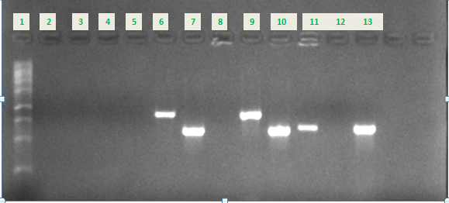

Well No. | Sample | Plasmid Pxo1  Pag gene | Plasmid Pxo2  Cap gene | Chromosomal  Sap gene | Results
1 | 1kb DNA Ladder |  |  |  | O.K.
2 | NTC |  |  |  | O.K.
3-5 | Sample 1 | Negative | Negative | Negative | Negative for B.anthracis
6-8 | Sample 2 | Positive | Positive | Negative | Positive for B.anthracis
9-11 | PC | Positive | Positive | Positive
12 | NTC |  |  |  | O.K.
13 | PC | Not Done | Not Done | Positive

Outbreak Section

Outbreak of Avian Influenza in Odisha, August 2024
Contributed by: Dr Mohd. Zuber¹, Dr Sidhartha Giri², Dr Manoj Kumar Panigrahi³, Dr Himanshu Chauhan⁴, Dr Sanket Kulkarni⁴
¹Consultant Epidemiologist, CSU-IDSP; ²Scientist-F, RMRC, Bhubaneswar; ³Respiratory Medicine Specialist, AIIMS, Bhubaneswar; ⁴Joint Director, NCDC
A multi-disciplinary central team was deployed to Odisha for monitoring the Avian Influenza containment plan implementation on 6th September 2024. The initial incident of chicken deaths reported in Villages Abalpur and Raichankradharpur in District Puri, on 23rd August 2024, prompting the Animal Husbandry Department to initiate control measures and surveillance, supplemented by active surveillance from the Health Department. On 7th September 2024 ICAR-NIHSAD, Bhopal, confirmed H5N1 in 2 additional epicenters, Villages Ender and |  | Balia in Kendrapara Districts (table 1 & figure 1). Furthermore, mortality was not reported in any other domestic and wild birds in Odisha. The animal husbandry department planned to collect 5% samples from such birds for testing of H5N1. The transmission of Avian Influenza in the state was beyond the expected seasonality in India which led to a significant economic loss to the farmers in the community. Out of 323 human samples collected (table 2) and sent to RMRC Bhubaneswar, 2 samples tested positive for Influenza A (H3N2)  and 1 sample tested positive for Influenza A (H1N1).

Sl No. | District | Epicentre | Infected Species | Date of Positive result | Date of completion of Culling
1 | Puri | Village Abalpur, Block Pipli | Chicken | 23-08-2024 | 31-08-2024
2 | Puri | Village RaiChakradharpur, Block Satyawadi | Chicken | 23-08-2024 | 31-08-2024
3 | Puri | Village Moteri, Block Delang | Chicken | 31-08-2024 | 04-09-2024
4 | Puri | Village Kottakasanga, Block Nimapada | Chicken | 31-08-2024 | 04-09-2024
5 | Kendrapara | Village Ender, Block Derabish | Chicken | 07-09-2024 | 11-09-2024
6 | Kendrapara | Village Balia, Block Derabish | Chicken | 07-09-2024 | 11-09-2024

Table 1. District wise epicenters of Avian Influenza Reported in Odisha

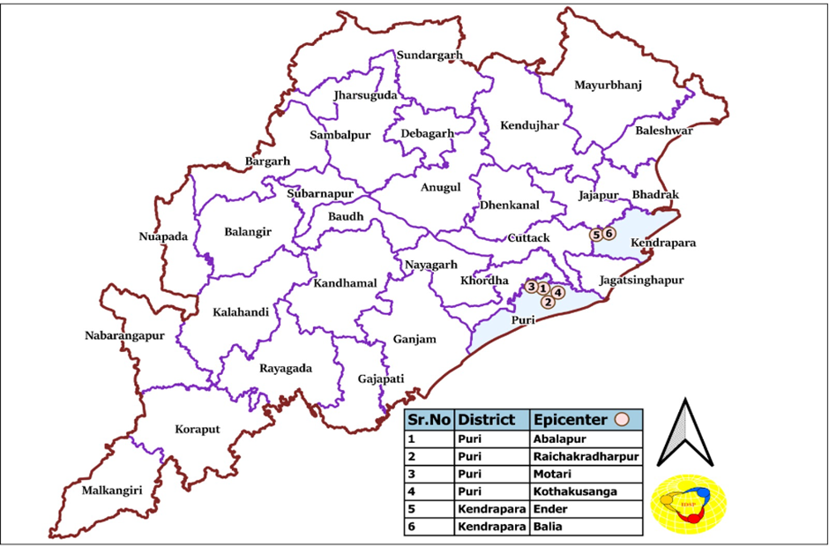
Figure. 1 Map of Odisha with 6 epicenters in Districts Puri, Kendrapara and bordering areas of Districts Cuttack and Jajpur

District | No. of human Samples collected | Result of samples tested at  RMRC Bhubaneswar
Puri | 219 | All samples Negative for Influenza A & B
Kendrapara | 59 | All samples Negative for Influenza A & B
Cuttack | 34 | 2 samples Positive for Influenza A (H3N2)
Jajpur | 0 | No samples collected
Jagatsinghpur | 11 | 1 sample positive for Influenza A (H1N1)
Total | 323 | 2 samples tested positive for Influenza A (H3N2) and 1 sample tested positive forInfluenza A (H1N1)
Table 2. Human Samples collected in Odisha August-September 2024

During the period of 7th-13th September 2024 the central team visited Districts Puri and Kendrapara in Odisha. Based on following observations the recommendations regarding containment of Avian Influenza in Odisha were shared with Director Health Services and Director Public Health, Government of Odisha.  Observations:  - The 5th day as first sample collection of cullers was calculated from the start date of culling instead the end of the culling operations in Block Delang, Puri.  - 30mg tablets and Suspension of Oseltamivir were not available at health facilities of Blocks Delang, Puri and Derabish, Kendrapara.  - The central team didn’t find any IEC material on Avian Influenza in the locality and at the poultry farms.  - Quarantine of cullers for 10 days after the culling operations was not followed at the four epicenters of District Puri.  - Majority of the poultry farms were without birds during the culling operation in Block Delang, Puri.  - Poultry farm owners, bird handlers and people living in the vicinity of epicenters were not given chemoprophylaxis of Oseltamivir 75mg in Block Delang and Derabish.  - Biosecurity measures at poultry farms and burial sites were inappropriate in the containment zone.  Recommendations:  - State health department to ensure chemoprophylaxis, isolation, testing of farm owners and bird handlers.  - Preparation of IEC/BCC materials for high-risk groups such as curlers, bird handlers, farm owners and surveillance workers.  - Implementation of the contingency plan for |  | management of human cases of Avian Influenza.  - Samples to be collected from cullers and farm workers irrespective of symptoms.  - Identification of ILI and SARI cases in the community through active surveillance in 0-3 km radius of the epicenter and passive surveillance in 3-10 km radius of epicenter for 10 days following the culling operations.  - Medical practitioners of government and private sector, health workers to be oriented on case definitions, sign and symptoms of avian influenza. 5% ILI, 100% SARI cases and immunocompromised patients to be tested for Influenza A.  - Prohibitions to be put in place regarding movement of birds and poultry after first death of bird/poultry is reported in an area. Decision on continuity or removal of prohibitions to be decided after results are received from NISHAD Bhopal.  - Biosecurity measures to be strictly followed in containment zone of 0-1 km radius of the epicentre.  Acknowledgement: The central team members - Dr. Mohd. Zuber, Dr. Sidhartha Giri and Dr. Manoj Kumar Panigrahi are thankful for the support provided by Dr. Suchitra Sasmal, Sr. RD RoHFW, Bhubaneswar, Dr. Bijay Kumar Mohapatra, Director Health Services, Odisha, Dr. Nilakantha Mishra, Director Public Health, Odisha, Dr. Prameela Baral, Additional Director Public Health, Odisha, Dr Ashok Paikaray, State Surveillance Officer, Odisha, Staff of State Surveillance Unit Odisha, District Surveillance Unit Puri and Kendrapara.

Field Epidemiological Investigation of AES/Chandipura Virus Cases and Deaths: Deployment of Central Team to Support Gujarat's State Epidemic Cell
Contributed by - Dr Kamlesh Mandriya¹, Dr Jariwala Devang², Dr Himanshu Chauhan³, Dr Tanzin Dikid³, Ms Aathira V. Dev⁴, Dr Betsy Varghese⁵,
Dr Amit Pritam Swain⁵, Dr Ngangom Kanchan⁵, Dr Sowntappan B⁵, Dr Jayesh. M Katira⁶, Dr Harshad Prajapati⁵, Dr Jayesh Solanki⁷
¹Consultant Epidemiologist, ²Assistant Director, ³Joint Director, ³Deputy Assistant Director, ⁵EIS Officer, ⁶State Nodal Officer, IDSP, Gujarat, ⁷Medical Officer, CH&FW, Gujarat

Introduction: The Chandipura virus (CHPV), an arbovirus belonging to the genus Vesiculovirus within the Rhabdoviridae family, has emerged as a significant public health concern in India. Recognized as an encephalitis-causing virus, CHPV predominantly affects children under 15 years of age, while adults exhibit resistance to natural infection. Transmitted by Phlebotomine sandflies, CHPV outbreaks have been documented in the Indian subcontinent, Sri Lanka, and Africa, with India witnessing severe epidemics, particularly in Maharashtra and Andhra Pradesh.  In July, Gujarat experienced a major CHPV outbreak across multiple districts, prompting swift intervention by a team of public health experts from the National Centre for Disease Control (NCDC). Their investigation entailed detailed outbreak analyses, descriptive epidemiological studies, and entomological surveillance to understand the virus transmission dynamics and implement control measures. The findings aim to inform future preparedness and response strategies against this emerging arbovirus.  Background: In the second week of July 2024, the Central Surveillance Unit of the Integrated Disease Surveillance Programme (IDSP) reported a cluster of Acute Encephalitis Syndrome (AES) cases and associated deaths in Gujarat. Laboratory testing at the National Institute of Virology (NIV), Pune, confirmed the presence of Chandipura virus (CHPV), an encephalitic arbovirus of significant public health concern in India and often leading to explosive outbreaks in endemic regions.  To support the Gujarat State Surveillance Unit in managing the outbreak, a multidisciplinary five-member team—comprising experts from the National Centre for Disease Control (NCDC) and CSU-IDSP—was deployed on July 23, 2024. The team included an Assistant Director (IDSP), two Epidemic Intelligence Service (EIS) officers, an |  | Epidemiologist, and an Entomologist. Upon arrival, the team conducted a situational analysis, coordinated with state health officials, and systematically investigated CHPV- positive AES cases and deaths across the affected regions. Given the outbreak's rapid spread across 25 of Gujarat's 41 districts/municipal corporations, sandfly surveillance was undertaken to identify potential vectors, while two additional EIS officers were deployed on August 5, 2024, to expedite case investigations and strengthen the outbreak response.  Methodology: The study was conducted in all affected districts of Gujarat where confirmed Chandipura virus (CHPV) cases were reported between July 1 and July 31, 2024.  - Case Identification: Enhanced passive surveillance was activated under the Integrated Disease Surveillance Programme (IDSP). The investigation team collaborated with District Health Authorities to review line lists of CHPV-positive Acute Encephalitis Syndrome (AES) cases.  - Entomological Surveillance: Sandfly-focused entomological investigations were conducted in households, cattle sheds, and abandoned buildings around CHPV-positive cases. Mosquitoes and ticks were also collected for vector analysis.  - Data Collection Tool:  - Confirmed CHPV Case Details: Obtained from State Surveillance Unit (SSU), Gujarat under the Integrated Disease Surveillance Programme (IDSP).  - Clinical Presentation: Extracted from case sheets available at the health facilities where patients were treated.  - Socio-Demographic and Environmental Exposures: Captured through a semi-structured questionnaire developed by the investigation team.

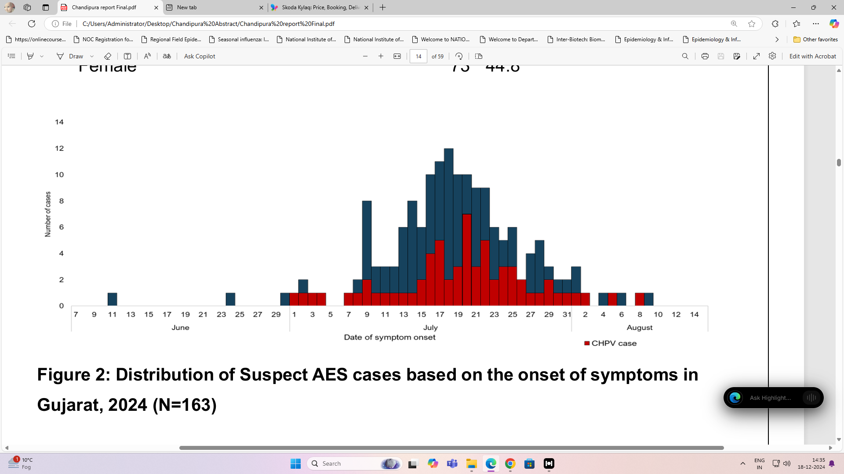
Fig 1 - Distribution of Suspected AES cases based on the onset of symptoms in Gujarat, 2024 (N=163)

Results:  Suspected Chandipura AES Cases - The line list of suspected Chandipura AES cases was obtained through enhanced passive surveillance activated by the Gujarat State Surveillance System. These cases served as the basis for identifying confirmed CHPV AES cases.  - Total Suspected Cases: 163 (as of August 14, 2024).  - Major Symptoms:  - Fever: 92%  - Convulsions: 65%  - Vomiting: 45%  - Diarrhea: 31%  - Altered Sensorium: 19%  The distribution and details of the suspected cases reflect the symptomatology and burden of the current outbreak.  2. Descriptive Epidemiology of Confirmed CHPV AES Cases  - Total Confirmed Cases: 54  - Geographical Distribution:  - 20 districts and 3 Municipal Corporations.  - Spread across 44 blocks (16.06% of Gujarat’s 274 blocks).  - Cases distributed in 54 villages with no village reporting more than one case.  - Case Fatality Rate (CFR): 50% (27 deaths among 54 confirmed cases).  - Outbreak Period: July 1 to July 31, 2024.  This data highlights the geographical dispersion, mortality burden, and sporadic clustering of confirmed CHPV AES cases.  - Entomological Surveillance - The entomological team conducted surveillance across 32 households in 9 districts (Ahmedabad, Gandhinagar, Vadodara, Mehsana, Panchmahal, Sabarkantha, Kheda, Aravalli, and Dahod). |  | - Sandfly Surveillance:  - Mean PMHD (Per Man-Hour Density): 9 (SD=8; Range: 1-32).  - Sandfly Samples Collected: 34 (13 males, 21 females).  - Identified Species:  - Sergentomyia spp.: Majority  - Sergentomyia babu: Identified in 4 samples  - Houses Positive for Sandflies: 25 (78.2%)  - Collection Sites: Dwelling and non-dwelling structures, including cattle sheds, abandoned structures, electric pump rooms, and outdoor toilets.  - Other Vectors Collected:  - Ticks: Haemaphysalis bispinosa and Hyalomma spp.  - Mosquitoes:  - Anopheles vagus (10)  - Anopheles subpictus (13)  - Culex quinquefasciatus (1)  - Culex gelides (1)  - Culex tritaeniorhyncus (1)  Entomological findings underscore the predominance of sandflies in and around affected households, confirming their critical role in CHPV transmission.  Public Health Actions Taken  Actions by the State:  - Enhanced Surveillance: Activated enhanced passive surveillance for AES cases and ensured rapid referral of patients to tertiary care hospitals for appropriate treatment.  - Vector Control Measures: Initiated IRS (Indoor Residual Spraying) and Malathion dusting in and around the households of confirmed CHPV cases to control sandfly vectors.

- Healthcare Worker Sensitization: Sensitized both private and government sector healthcare workers on Chandipura virus disease, including its identification, management, and reporting.  - Testing Facilities: Initiated in-state CHPV testing at the Gujarat Biotechnology Research Centre (GBRC) for faster diagnosis and response.  2. Actions by the NCDC Team:  - Training and Capacity Building: Provided training in vector management and case management based on field findings.  - Healthcare Worker Awareness: Conducted awareness sessions at health facilities and during field visits for frontline healthcare workers (ASHA workers, ANM, MPW) on:  - Chandipura virus disease  - Vector identification and control  - Fever surveillance  - Importance of early referral for suspected cases  - Community Awareness: Educated families in affected households and neighboring areas on:  - Disease awareness and its symptoms  - Control measures to prevent vector bites  - Importance of proper and early referral to healthcare facilities.  Recommendations  1. Surveillance and Case Management  - AES Syndromic Surveillance: Strengthen AES and fever surveillance during the transmission season among healthcare workers and local practitioners to ensure early identification and prompt referral to facilities with intensive care capabilities.  - Training for Physicians: Train physicians to manage AES complications, particularly in pediatric populations, such as Multiple Organ Dysfunction Syndrome (MODS).  - Management Protocol and Lab Capacity: The state should circulate Chandipura virus management protocols and augment laboratory capacity for timely diagnosis and management. |  | - Entomological Surveillance and Vector Control  - Pre-Transmission Season Surveillance: Strengthen entomological surveillance during the pre-transmission season.  - Prioritization for IRS: Prioritize houses with sandfly densities above 5 PMHD for vector control measures, such as Indoor Residual Spraying (IRS).  3. Community Awareness and Behavior Change  - Behavior Change Communication (BCC): Implement community-level awareness programs to promote personal protective measures, such as:  - Sleeping indoors on a cot and covered with a sheet.  - Improving housing conditions, including better ventilation and filling crevices to prevent sandfly breeding.  4. Interdepartmental Coordination  - Strengthening Coordination: Improve interdepartmental collaboration between:  - Health Department and ICDS for enhancing nutritional status of children.  - Health Department and Animal Husbandry to promote a One Health approach.  - Rural and Urban Development Departments for improving housing infrastructure.  - Training Initiatives: Strengthen entomological surveillance through focused training programs for relevant personnel.  Outbreak Investigation of Acute Diarrhoeal Disease in Uprari Village, Almora, July 2025  Contributed by: Dr Farida Khatoon¹, Dr Gopi Kumbha², Dr Sushma Choudhary³  ¹India EIS officer, NCDC; ²SAFETYNET Fellow, ³Program Advisor (SAFETYNET)  On July 9th, 2024, an Early Warning Signal (EWS) reported a cluster of acute diarrheal disease (ADD) cases in Uprari village, Tadikhet block, Almora district, from the previous three days. An Epidemic Intelligence Service Officer (EISO) from the Department of Public Health, Uttarakhand, and a Consultant Epidemiologist from the National Centre for Disease Control were deployed on July 10th,

2024. On the same day, the Almora district Epidemiologist and Microbiologist also visited Uprari village and interacted with a medical officer and a few cases. To describe the epidemiology in terms of time, place, and person distribution  Methodology  The study was conducted in Uprari village, Tarikhet Block, Almora District. The village population was 505 and 106 households. Suspected cases definition: Three or more loose stools in 24 hours in a resident of Uprari village from 25th June to 15th July 2024. Study tools: We collected data using a semi-structured questionnaire. An active search for suspect cases was conducted in the village of Uprari, with the support of medical officer. The team was composed of an Epidemiologist, an Epidemic Intelligence Service Officer, a Pharmacist, Nursing Officer (NO), a Community Health Officer (CHO), an Auxiliary Nurse Midwife (ANM), ASHA worker, and Facilitator.  Laboratory investigations: The district microbiologist collected water samples from a few drinking water tanks. Blood and Stool samples were collected by the CHC team and sent to Soban Singh Jeena Government of Medical Sciences & Research, Almora. Data analysis: Descriptive analysis of cases by time, place, and person. Calculation of Median, range, proportions, and attack rates.  Results  We conducted the survey across 107 households and 505 residents in the Uprari village. For the descriptive analysis, we included 33 cases. The household attack rate was 25.2% and overall attack rate was 6.5%. No one hospitalized and mortality was reported during this outbreak. The median age of cases is 32 years, with a range (3 to 70). The age wise attack rate 11.2% for those over 61 years. The attack rate among females was 7.7%, education, 33% of cases have graduate-level |  | education or higher, occupation, 33% are housewives.  The place distribution of cases. The maximum number houses with cases are clustered around water tanks of three, and four. The first clinical symptom presented in the cases was diarrhoea (17), followed by abdominal pain (12). The patients who received treatment, 61% were given antibiotics. 94% of cases using water from tank three and four. Before the onset of symptoms, 58% had domestic water usage, and 94% had toilet facilities. Households had access to running water taps (61%) and soap or hand wash (58%). The outcomes of the cases were 54% recovered, 39% under treatment. The organisms identified was E. coli and Enterococcus from water tanks of three, four, and six, and Citrobacter from tanks four and six.  Conclusion: ADD outbreak at Uprari Village, Tadikhet block, Almora district, July. Continuing common water source contamination. Most of the cases drunk water from tank 3 and 4. E. coli, Enterococcus and Citrobacter found from tank 3, 4, and 6.  Public health action: We provided training on the importance of chlorination for ensuring safe drinking water to the community. Health education to the community during the field activity on boiling of water before consumption. We also measured and chlorinated all water tanks in Uprari village.  Short term recommendations: Chlorination of drinking water should be ensured in xx days/weeks. For every three days water tank cleaning and chlorination at night time or afternoon. Household level: Boiling and using of chlorine tablets. All water tank measurement in the village. Long term recommendations: Regular periodic training on chlorination for ASHA, ANM, CHOs. Regular water testing for chlorination by water department, and ANM, Multipurpose worker. ASHA: To maintain the registers for water cleaning and chlorination details.

Fig 1: Number of Acute Diarrhoeal Disease by Date of Onset, Uprari Village July 2024 (N-33)
*Surveillance is going on. #H2H: House to House Survey
NCDC News

EIS Officers train in R Programming for Enhanced Epidemiological Analysis
Contributed by: Dr Vijaypal Singh¹ Dr Nivethitha Krishnan², Dr Ramesh Chandra³, Dr Tanzin Dikid³
¹Epidemiologist; ²SAFETYNET Fellow; ³Joint Director, NCDC
The India Epidemic Intelligence Service (EIS) program recently concluded a successful five-day workshop focused on equipping its officers with advanced data analysis skills. Held from July 8-12, 2024, the workshop, titled "Introduction to Field Epidemiological Analytics using R Software," was organized by the EIS Cell, Epidemiology Division of the National Centre for Disease Control (NCDC) in New Delhi. This initiative was conducted in collaboration with the World Health Organization, South East Asia Region Office (WHO, SEARO) and facilitated by the South Asia Field Epidemiology and Technology Network (SAFETYNET).  The workshop aimed to empower EIS officers with fundamental training in R programming, a powerful tool for analyzing and interpreting epidemiological data. By mastering R, participants gained the ability to delve deeper into critical aspects of disease outbreaks, including transmissibility, severity, and impact.  Workshop Highlights:  - Comprehensive Curriculum: Developed by Ms. Yuka Jinnai, Technical Officer at WHO SEARO and the NCDC EIS division, the curriculum provided a comprehensive overview of R, covering installation, navigation, data manipulation, visualization, |  | and outbreak data analysis.  - Expert Instruction: Ms. Jinnai provided expert guidance and support throughout the workshop.  - Engaged Participants: The workshop saw active participation from around 18 EIS officers from cohorts 9 and 10, as well as 5 NCDC consultants.  - Practical Application: Participants consolidated their learning through a hands-on group project, analyzing datasets and presenting their findings using R markdown.  Positive Feedback and Outcomes:  A key highlight of the workshop was its positive reception by the participants. Post-training assessments revealed that most EIS officers found the workshop to be highly beneficial and expressed confidence in their ability to utilize R for epidemiological analysis. This outcome underscores the effectiveness of the program in enhancing the analytical capabilities of India's public health workforce.  By equipping EIS officers with R programming skills, this workshop has significantly strengthened India's capacity to effectively analyze and respond to public health threats. The initiative reflects a commitment to leveraging technology and data-driven approaches for improved disease surveillance and outbreak management.

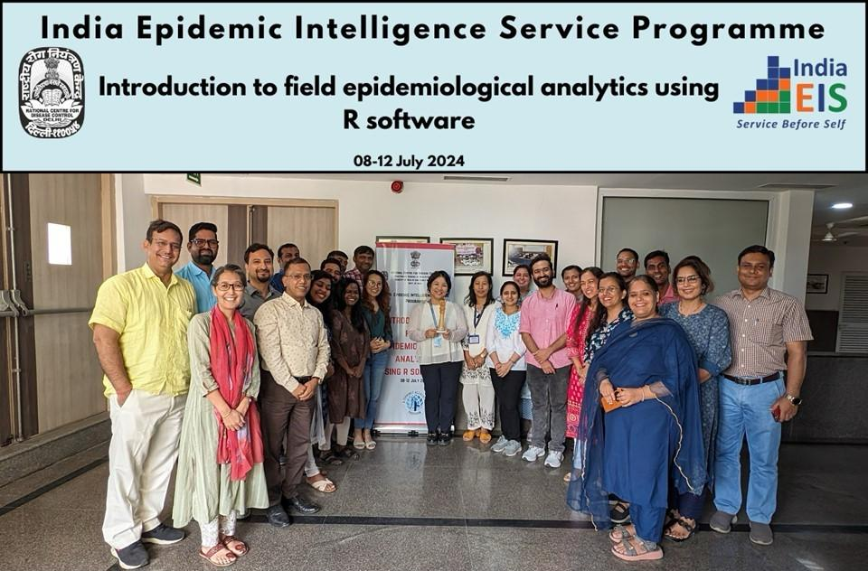

Public Health Emergency and Disaster Management (PHEDM) Five-Tiered Capacity-Building Approach  Contributed by: Dr Himanshu Chauhan¹, Dr Pranay Verma¹  ¹Joint Director  Figure 1: PHEDM Five-Tiered Capacity Building Approach  Recognizing that public health emergencies and disasters are two sides of the same coin, often leading to one another, there was a need to train both systems as a single entity. PHEDM Five-Tiered Capacity-Building Approach is an innovative initiative designed, developed, and implemented through a collaborative partnership involving the IDSP-NCDC, MoHFW; National Institute of Disaster Management (NIDM), MHA and Centers for Disease Control and Prevention (CDC)-India. It aims to strengthen capabilities at all levels, from local communities (Tier-I and II) to the District and State levels (Tier-III) to the strategic level for policy and decision-makers (Tier-IV and V) (Figure 1).  PHEDM-Tier-III Training Programs  The PHEDM Tier-III training program specifically trains a cadre of professionals, making them well-oriented in the principles of the Incident Response System (IRS) and the Emergency Operations Centre (EOC). The Training Programs have made significant progress in enhancing preparedness and |  | response capabilities in managing public health emergencies and disasters by ensuring multi-sectoral coordination. Between January 2022 and September 2024, ten trainings were conducted, covering 5 States capacitating 484 participants, including 409 mentees and 75 mentors. Over the three years, the program witnessed substantial growth.  The program adopts a mentor–mentee framework, fostering multidisciplinary participation from the Health, Disaster Management, and Animal Husbandry departments. This initiative has successfully created a strong network of mentors and mentees to enhance emergency preparedness across key sectors. With its growing reach and impact, the program continues to empower stakeholders for a more resilient and prepared future.  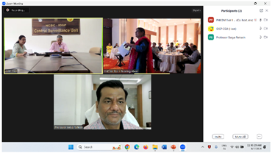  Figure 3: Interaction of NCDC and NIDM officials with PHEDM Tier-II training participant virtually  NCDC, NIDM, and the Rajasthan State, in collaboration with CDC-India, piloted the PHEDM Tier-II Training in Alwar District, Rajasthan, on August 07-08, 2024. The primary objective was to familiarize participants with the Tier-II training package and gather their valuable feedback. 52 participants, mainly frontline workers, attended the training from 11 key line departments (Figure 2).  The PHEDM Five-Tiered Capacity-Building approach is a joint initiative of IDSP-NCDC, NIDM, and CDC-India. We sincerely acknowledge and appreciate the valuable contributions of all those involved.

NCDC Branches
National Centre for Disease Control, Varanasi Branch statement of work done from Jul 2024 to Sep 2024 (3rd quarter)
Contributed by: Dr Prateek Kumar Singh¹, Sh Awanindra Dwivedi², Sh Anukesh Singh³
¹Medical Officer & OIC; ²Research Assistant; ³Technician

NCDC Varanasi conducted a three days LF Elimination training of MOs/Biologist/DPOs from 20.09.2024 to 27.09.2024 in which 13 trainees from Karnataka & Assam attended the training. Didactic classroom lectures and field training sessions as per training curriculum were conducted. A training of House Keeping Staff on Vector Borne Disease & Control measures was conducted on 18.07.2024 at LBSI Airport with 61 Participants trained about different vectors like Anopheles, Aedes, Culex, Houseflies etc and control measures to reduce their source of breeding. The 5th Joint Public Health Committee Meeting on Monkey Pox Sensitization & awareness was conducted on 23.08.2024 at Conference Hall, LBSI Airport with 37 participants including in charges of all the stake holders at LBSI Airport. Training of all the Immigration and Customs Staff was also conducted on Monkey Pox Awareness on 24.08.2024 with 18 participants in attendance. NCDC Varanasi was also involved in conducting STH surveys in the States of Uttarakhand & Rajasthan from 07.07.2024 to 27.07.2024.  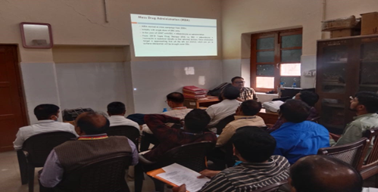  Img1: Ongoing lecture during LFE training programme |  | 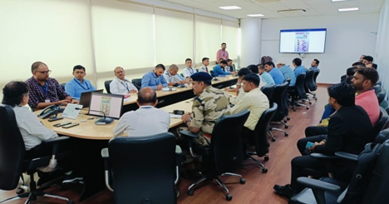  Img2: Awareness session on Monkey pox held for various  staff and other stakeholders at LBSI Airport, Varanasi  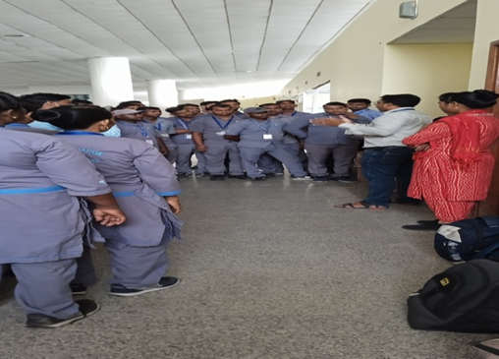  Img3: Housekeeping staff training at LBSI Airport on vector borne diseases  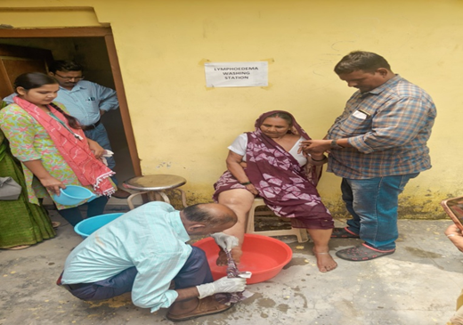  Img4: Lymphedema washing demonstration to trainees

Global Disease Alert

Contributed by: NFP IHR Secretariat, Division of Public Health Preparedness & NCD

1. Mpox – African Region
22 August 2024
As of mid-2024, the mpox outbreak in the Democratic Republic of the Congo (DRC) and neighboring African countries prompted the WHO to declare a Public Health Emergency of International Concern (PHEIC) on 14 August 2024. The DRC reported 7,851 cases, including 384 deaths (CFR 4.9%), across 22 provinces, with challenges including high incidence in endemic areas, geographic spread, a novel clade I strain, sustained community transmission via sexual contact, limited resources, and vaccine unavailability. Neighboring countries—Burundi, Kenya, Rwanda, Uganda, Côte d’Ivoire, and South Africa—have also reported cases, with South Africa noting 20 cases and three deaths (CFR 15%) between May and July 2024, primarily linked to sexual contact. Response efforts include enhanced surveillance, laboratory diagnostics, risk communication emphasizing sexual transmission, and infection prevention and control (IPC) measures. Vaccination strategies targeting high-risk groups are under development, with clinical trials and vaccine procurement discussions ongoing. WHO and Africa CDC are coordinating regional efforts to strengthen surveillance, clinical care, and readiness, with countries activating emergency operations, deploying Rapid Response Teams, and integrating mpox response into existing health programs. Public sensitization campaigns and cross-border coordination remain crucial to managing the outbreak and mitigating risks.
2. Acute encephalitis syndrome due to Chandipura virus – India
23 August 2024
Between early June and 15 August 2024, India reported 245 cases of acute encephalitis syndrome (AES), including 82 deaths (CFR 33%), with 64 confirmed cases of Chandipura virus (CHPV) infection, marking the largest CHPV outbreak in two decades. Favorable monsoon conditions are facilitating vector proliferation, raising concerns of further transmission. The Ministry of Health and Family Welfare has deployed the National Joint Outbreak Response Team (NJORT) to Gujarat for epidemiological investigations and public health interventions. Measures include insecticidal spraying for vector control, public health awareness campaigns, and enhanced research by the Gujarat Biotechnology Research Centre (GBRC). National advisories from NCDC and NCVBDC guide neighboring states. Gujarat has intensified community engagement, medical sensitization, and timely case referrals, while Rajasthan issued alerts and advisories in border districts following a confirmed CHPV case in Dungarpur.
3. Oropouche virus disease - Region of the Americas
23 August 2024
On 27 May 2024, Cuba reported its first outbreaks of Oropouche virus disease (OVD) in Santiago de Cuba and Cienfuegos provinces, marking the disease’s spread beyond its historical range in the Amazon region. Transmitted by midges, the virus has caused an increase in cases across the Americas, including Bolivia, Brazil, Colombia, Cuba, and Peru. As of 20 July 2024, there were 8,078 confirmed cases, including two deaths, with Brazil also reporting fetal deaths and potential vertical transmission. In response, Cuba activated a national plan for arboviruses, focusing on epidemiological surveillance, vector control, medical training, and public awareness. The Pan American Health Organization (PAHO) has issued regional updates and developed laboratory testing algorithms, enhancing molecular testing capacity in Latin America. Brazil has implemented entomo-epidemiological actions, monitoring vector populations and supporting local responses. Research efforts are ongoing to study the virus's genomic characteristics, clinical manifestations, and transmission cycle. PAHO continues to support affected countries with technical expertise.
4. Mpox – Sweden
30 August 2024
On 15 August 2024, Sweden reported its first laboratory-confirmed case of clade Ib monkeypox virus (MPXV), marking the first case of this clade outside the African Region. The patient had traveled to an outbreak-affected country in Africa. In response, they are monitoring close contacts.
5. Avian Influenza A(H5N1) - Cambodia
2 September 2024
On 20 August 2024, Cambodia reported a confirmed case of human infection with avian influenza A(H5N1) in a 15-year-old child, marking one of 10 human cases in 2024. The country has seen 72 cases and 43 deaths since 2003. Public health response includes investigations into animal transmission, monitoring close contacts with prophylactic treatment, health education campaigns, and stamping-out measures like culling poultry and disinfecting affected areas.
6. Influenza A(H1N1) variant virus - Viet Nam
4 September 2024
On 19 August 2024, Vietnam reported its first-ever human case of infection with swine-origin influenza A(H1N1) variant (v) virus in Son La province, with the source of exposure unknown. Public health response includes enhanced surveillance, coordinated human-animal health efforts, and initiated outbreak investigations, with the Son La Provincial Center for Disease Control working with local authorities on contact tracing and preventive measures.
7. Avian Influenza A(H9N2) – Ghana
20 September 2024
On 26 August 2024, Ghana reported its first human case of infection with avian influenza A(H9N2), confirmed in a child under five years old with no known exposure to poultry or sick individuals. In response, the government has enhanced case surveillance, initiated epidemiological investigations, and is monitoring close contacts. Public risk communication campaigns are also underway to raise awareness and promote self-protection, particularly among high-risk occupational groups.
8. Marburg virus disease – Rwanda
30 September 2024
On 27 September 2024, Rwanda confirmed its first outbreak of Marburg virus disease (MVD), with 26 cases and 8 deaths reported by 29 September, primarily affecting healthcare workers in Kigali. The government, in coordination with WHO and partners, has initiated public health response, including contact tracing, isolation of suspected cases, and infection prevention measures in healthcare facilities. Public health education, including a hotline for reporting symptoms, is underway.

Source: WHO
NCDC Buzz

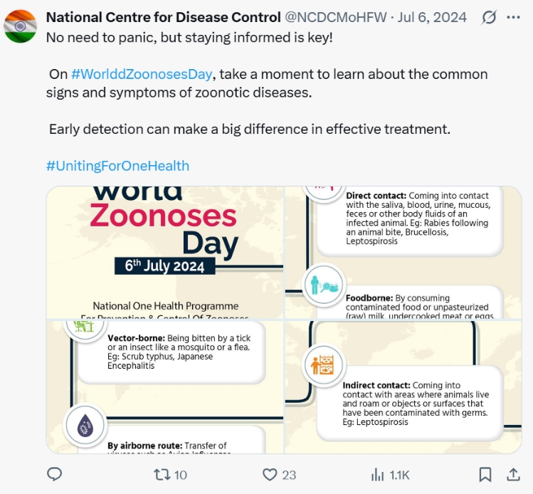 |  | 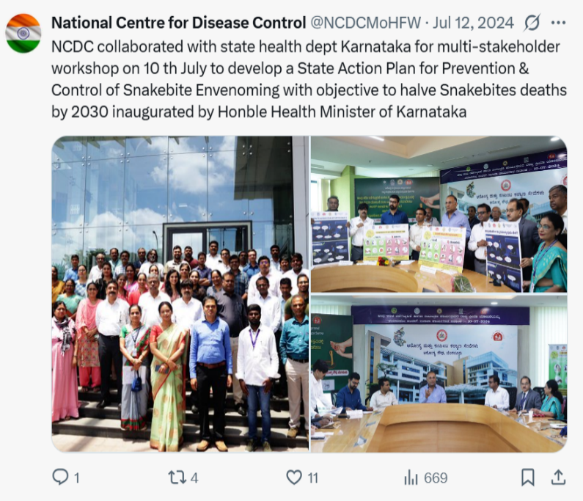
 |  | 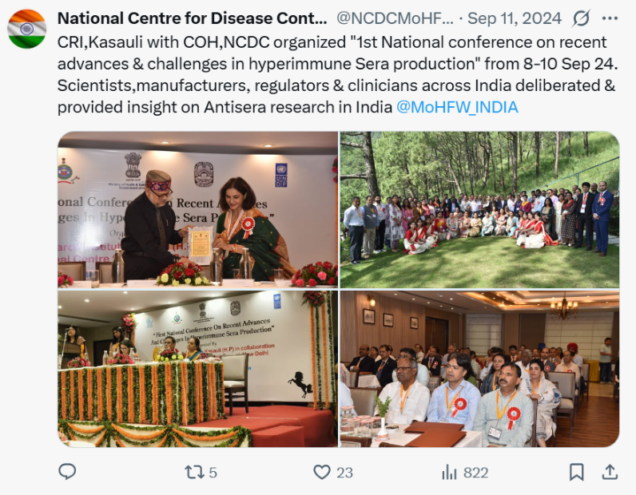
Editorial Board
Advisor Editorial board Prof. (Dr.) Atul Goel
Chief Editor: Dr. Anil Kumar
Executive Editor Dr. Sandhya Kabra
Assistant Executive Editor Dr. Meera Dhuria
Editorial Panel: Editorial Panel Drs. Arti Bahl, Aakash Shrivastava, Simrita Singh, Tanzin Dikid,
Himanshu Chauhan, Simmi Tiwari, Vinay Garg, Monil Singhai, Purva Sarkate
Editorial Coordinator: Dr. Suneet Kaur
Design and Layout: Abhishek Saini
For comments and inputs, e-mail ncdcnewsletter21@gmail.com
Digital Library section. Address: National Centre for Disease Control, 22-Sham Nath Marg, Delhi — 110054. India the editorial board does not hold any responsibility for the materials contained in this publication which is based on information available from various sources. Reproduction of material from the NCDC Newsletter, in part or in whole, is encouraged, as long as credits and acknowledgement are given. The article/s may be cited as Author, Year, Article Title, NCDC Newsletter, Volume (), Issue () Quarter, Page
Online version of NCDC Newsletter is available at NCDC website www.ncdc.gov.in under Resource/Digital Library Section

